Sign Guide – Cavan Monaghan Township
Here are some rules you should be aware of in addition to the sign specific rules that follow in the next section.
Rule | Picture |  |  | Description |  | By-law Rules
Sight Triangle & Sign Placement | 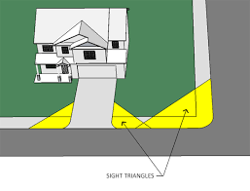 |  |  | A “sight Triangle” is an unobstructed triangular area where if something is placed there it could obstruct the view of oncoming traffic. This could be the view of someone in a vehicle that is on another street at an intersection. It could also be the view of someone in a vehicle wishing to exit a lane or driveway onto a street.  Although circumstances will vary according to the topography of the area, in general a sign placed here should not be more than 0.6 metres (24”) above the elevation of the centreline of the abutting street.  All Signs shall be on private property. It should also be noted that the Lot Line (property Line) will also have a bearing on the placement and height of the sign. |  | 3.10 Location of Signs  No sign shall be located in such a manner as to impede the view of any highway intersection or railroad grade crossing or any ingress and/or egress from private or public property or where, in the opinion of the road authority having jurisdiction, it may be confused with or impair the view of any authorized traffic sign, signal or device. If a sign falls within jurisdiction of another governmental authority, input from the applicable  authority will be sought.  4.4 Ground Signs  f. A ground sign shall be located at least 3.0 metres from the property line of any adjacent residence.  g. A ground sign shall be located at least 1.5 metres from the property line of any adjacent commercial, employment, institutional zone or municipal public right of way.
Existing Signs |  |  |  | These are signs that have been erected prior to this By-law coming into existence on May 3, 2021. |  | 3.12 Existing Signs  a. This By-law shall not apply so as to require any sign that was lawfully erected or displayed on the date this By-law comes into full force and effect that does not comply with the provisions of this By-law, to be made to comply with this By-law so long as the sign is  not altered.  b. If any sign legally existing on the date this By-law comes into full force and effect is removed, relocated or deemed by the Chief  Building Official or his/her designate to be substantially altered, the sign shall be replaced or upgraded only in accordance with all the requirements of this By-law.  c. Subsection a. does not apply to signs located on Municipal Property.
Maintenance | 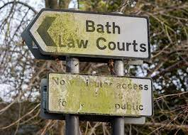 |  |  | Signs must be maintained for safety and appearance. |  | 3.13 Maintenance  Every sign shall be kept clean, neatly painted, well maintained and in good state of repair as to safety and appearance. No person shall permit any sign to become unsafe. Failure of maintenance requirements is subject to section 6.2c
Illumination |  |  |  | Signs may be illuminated according to the rules stipulated. |  | 3.14 Illumination  a. Signs may be illuminated unless otherwise expressly prohibited by this By-law.  b. No illumination of a sign shall spill beyond the face of the sign such that light interferes with the enjoyment of neighbouring lands or interferes with the visibility on nearby streets.
Compliance & By-law Conflict |  |  |  | All signs in the Township are controlled by the Sign By-law.  Where there is a conflict, the most restrictive bylaw applies. |  | 3.2 Effect of this By-law  No person shall erect, display or alter, or cause the same, any sign within the limits of the Township of Cavan Monaghan except in compliance with this By-law.  This By-law shall not be effective to reduce or mitigate any restrictions lawfully imposed by a governmental authority having jurisdiction to make such restrictions. The most restrictive of all the regulations shall prevail.
C.I.P.  Community Improvement Plan  Areas | 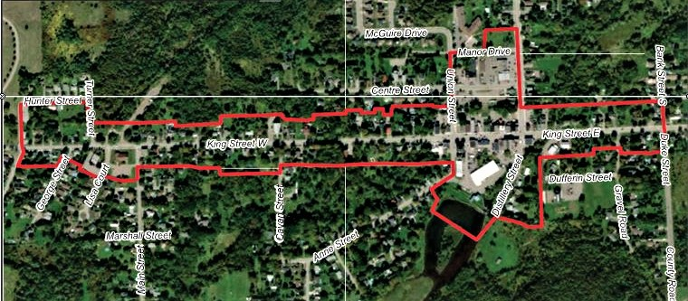 |  |  | There are certain areas where the Community Improvement Plan applies. In these areas, the sign may have to meet different rules. In particular, appearance of the sign may be regulated.  This rule is attached to each type of sign in the guide that typically may be affected.  For more information visit the CIP web page.  [Link to page: https://www.cavanmonaghan.net/en/build-and-invest/community-improvement-plan.aspx] |  | 5.7. Community Improvement Plan Areas  All signs within a Community Improvement Plan Area may be subject to the supplementary regulations or design guidelines developed and  approved for those CIP Area(s). These regulations or design guidelines are in addition to those contained elsewhere in the By-law and shall take precedence on those points which conflict.
IMPORTANT
The Sign By-law and the Zoning By-law are the final authority. This chart is a quick reference to help you understand the rules more easily.
There are some things found in the By-laws, that are missing or difficult to put in a chart format.
The pictures represent a type of sign. There may be variations in size, colour or sign structure. Read the descriptions carefully.
HOW TO USE THE GUIDE
- Find for the picture that shows the sign you are looking for.
- Read the description of the sign to verify it is what you are looking for.
- Check the Sign By-law column to see what the rules are for that sign.
- Check the zoning By-law column to see if the sign is allowed in your zone and if there are extra rules you need to consider.
Type |  | Picture | Sign Description |  | By-law Rules |  | Zoning Rules  Only use the sign in the zones listed
Abandoned Sign  3.15 Prohibited Signs |  |  | “Abandoned Sign” shall mean a sign located on property which becomes vacant and unoccupied for a period of ninety (90) days or more, or any sign which pertains to a time, event or purpose 48 hours after which it no longer applies. |  | 3.15 Prohibited Signs  a. Abandoned sign
Animated Sign  3.15 Prohibited Signs |  |  | “Animated Sign” shall mean a sign whose sign face moves in whole or in part and includes flashing, chase lighting, or electronic message which is stagnant for less than sixty (60) seconds or rotating sign but does not include a clock, a time, date or temperature display. |  | 3.15 Prohibited Signs  b. Animated sign
Awning |  |  | “Awning” shall mean a retractable or non-retractable roof-like structure constructed of canvas or canvas-like material (which may have displayed thereon a message) supported by a frame that projects from, is attached to and is supported by a building. |  | See also – “Fascia Sign” for details  o. “Fascia Sign” … Any message displayed on an awning or marquee, whether projecting over a street or not, shall be deemed a fascia sign for the purposes of this By-law. |  | 5.4. Institutional Zones  5.5. Commercial and Employment Zones  5.7. Community Improvement Plan Areas  See C.I.P in the “Rules” section above.
Banner  3.15 Prohibited Signs |  | 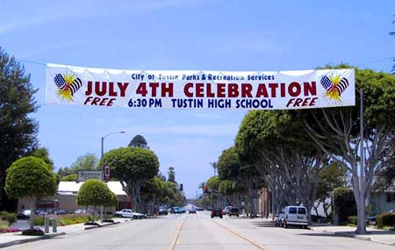 | “Banner Sign” shall mean a temporary sign made of vinyl, cloth, canvas or other like material. |  | 3.15 Prohibited Signs  c. A banner, other than a banner located within a public road allowance which has been given approval by Council.
Billboard Sign |  |  | “Billboard Sign” shall mean a sign structure to which advertising copy is fastened in such a manner as to permit its periodic replacement and which displays goods, products, services or facilities that are not available at the location of the sign and/or which directs or invites a person to location different from which the sign is located, and does not exceed 60 square metres in size. |  | 3.11 Number of Signs  a. Off-premise Signs  A maximum of one (1) off-premise sign may be erected or displayed on one lot.  3.14 Illumination  a. Signs may be illuminated unless otherwise expressly prohibited by this By-law.  b. No illumination of a sign shall spill beyond the face of the sign such that light interferes with the enjoyment of neighbouring lands or interferes with the visibility on nearby streets. |  | 5.6. Rural and Agricultural Zones  b. Billboard signs are permitted on Rural and Agriculturally Zoned parcels with frontage on County roads and Provincial Highways subject to the regulations and permit requirements of the governing road authority. No additional municipal permits are required;  Clarification: A municipal permit would be required for County roads unless the sign is on the road allowance in which case it would require a County Sign Permit.  See the charts for clarification about County Roads and Highways on the Signs page of the web site.  [Link to “First Step” heading on web page]
Black Fluorescent Sign |  | 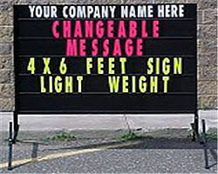 | “Black Fluorescent Sign” shall mean a permanent sign or mobile sign containing large changeable letters.  Could be fixed or moveable. See specific sign type for further details. |  | See Readograph Sign Type for Details |  | 5.4. Institutional Zones  5.5. Commercial and Employment Zones  5.7. Community Improvement Plan Areas  See C.I.P in the “Rules” section above.
Block Parent or Similar Signs |  | 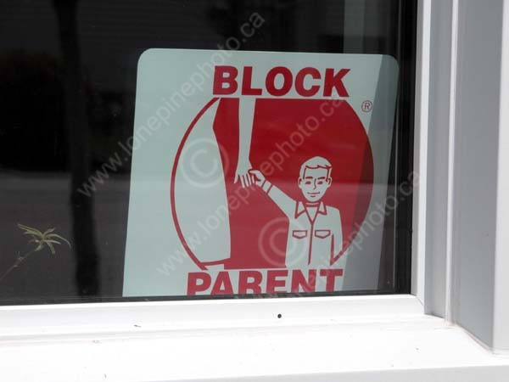 |  |  |  |  | 5.3. Residential Zones  g. Block Parent or similar signs
Civic Address Sign |  | 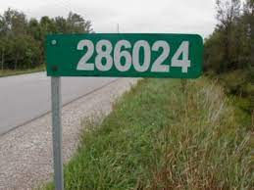 | “Civic Address Sign” shall mean a standardized sign supplied by the municipality and which is installed at or near the street line. |  | 3.8 Exemptions  No permit shall be required…  I. Civic address signs not exceeding 0.2 square metres in sign area. |  | 5.2 Permitted in all zones except Natural Core.  5.2.6. Civic Address Signs  a. Civic address signs shall have a maximum sign area of 0.2 square metres.
Contractor’s Sign |  | 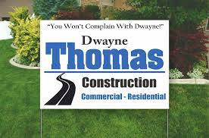 | Contractor’s Sign” shall mean a single or double faced temporary on-premise sign containing the name of the contractor or the name of the product being used for an on-going construction, renovation or maintenance project on a lot, where such sign shall be removed upon completion of the work. |  |  |  | 5.2 Permitted in all zones except Natural Core.  5.2.2. Contractor’s Signs  a. Contractor’s signs shall be permitted in any zone on a lot where there is active and ongoing construction by the business or person so indicated on the sign and shall be removed upon completion of construction;  b. Contractor’s signs shall not have a sign area exceeding 1 .5 square metres; and  c. Contractor’s signs may be located adjacent to any lot line including a street line.  5.7. Community Improvement Plan Areas  See C.I.P in the “Rules” section above.
Damaged or Unsafe Sign  3.15 Prohibited Signs |  | 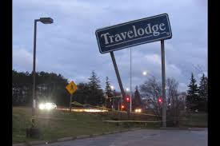 | Any sign structure in a state of disrepair or in an unsafe, damaged or hazardous condition. |  | 3.15 Prohibited Signs  j. Any sign structure in a state of disrepair or in an unsafe, damaged or hazardous condition
Developer’s Sign |  |  | “Developer’s Sign” shall mean a single or double faced temporary on-premise sign used to identify a development or redevelopment project on a lot or establishment or a subdivision, where such sign is removed upon completion of the development project. It shall have a maximum sign area of 9 square metres.  NOTE:  Where there is a conflict, the most restrictive bylaw applies. In this case the maximum 9 square metre sign area applies. |  | 3.10 Location of Signs  No sign shall be located in such a manner as to impede the view of any highway intersection or railroad grade crossing or any ingress and/or egress from private or public property or where, in the opinion of the road authority having jurisdiction, it may be confused with or impair the view of any authorized traffic sign, signal or device. If a sign falls within jurisdiction of another governmental authority, input from the applicable  authority will be sought. |  | 5.2 Permitted in all zones except Natural Core.  5.2.3. Developer’s Signs  a. Developer’s signs may be permitted in any zone on a lot that is subject to a current or proposed development or redevelopment project;  b. A maximum of one (1) developer’s sign shall be permitted on a lot for each separate street onto which the lot subject to the development project fronts;  c. Developer’s signs shall be removed within twenty-one (21) days from the date of completion of the development or redevelopment project;  d. The maximum sign area for each developer’s sign shall be 0.1 square metres for each 1.5 metres of street frontage, but in no case shall exceed 14 square metres in area;  e. Developer’s signs shall be deemed to be Ground Signs for setback purposes, and therefore subject to the relevant policies of Section 4.4 of this By-law; and  f. The maximum height of a developer’s sign shall be 4.6 metres.  5.7. Community Improvement Plan Areas  See C.I.P in the “Rules” section above.
Directional Sign – Off Premise |  |  | “Directional Sign, Off-premise” shall mean an off-premise sign that is used to guide vehicular and pedestrian traffic to a lot or business. The sign shall contain only the name of the business or enterprise, the logo and an arrow or other form of directional indicator and shall have a maximum sign area of 3 square metres.  See Specific Sign Type for Further Rules. |  | 3.10 Location of Signs  No sign shall be located in such a manner as to impede the view of any highway intersection or railroad grade crossing or any ingress and/or egress from private or public property or where, in the opinion of the road authority having jurisdiction, it may be confused with or impair the view of any authorized traffic sign, signal or device. If a sign falls within jurisdiction of another governmental authority, input from the applicable  authority will be sought.  3.11 Number of Signs  a. Off-premise Signs  A maximum of one (1) off-premise sign may be erected or displayed on one lot.  3.14 Illumination  a. Signs may be illuminated unless otherwise expressly prohibited by this By-law.  b. No illumination of a sign shall spill beyond the face of the sign such that light interferes with the enjoyment of neighbouring lands or interferes with the visibility on nearby streets. |  | 5.2 Permitted in all zones except Natural Core.  5.7. Community Improvement Plan Areas  See C.I.P in the “Rules” section above.
Directional Sign – On Premise |  | 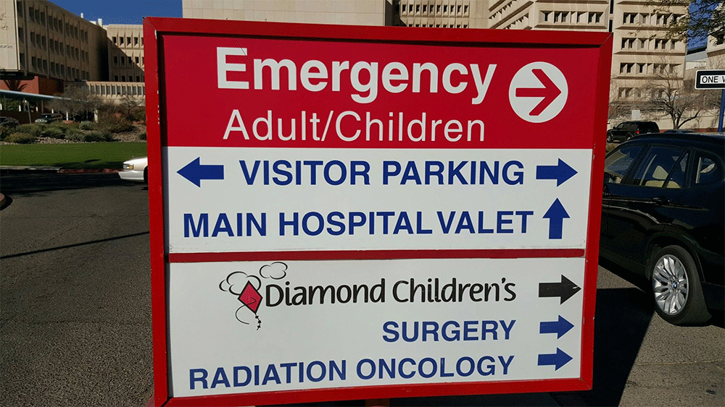 | “Directional Sign, On-premise” shall mean an on-premise sign that is used to guide vehicular and pedestrian traffic on a lot, such as entry or exit signage, or on-site parking signage and includes menu signage and similar on-site instructional signage, but shall not include any advertising matter. The sign shall have a maximum sign area of 0.5 square metres.  See Specific Sign Type for Further Rules. |  | 3.8 Exemptions  No permit shall be required…  e. On-premise directional signage.  3.14 Illumination  a. Signs may be illuminated unless otherwise expressly prohibited by this By-law.  b. No illumination of a sign shall spill beyond the face of the sign such that light interferes with the enjoyment of neighbouring lands or interferes with the visibility on nearby streets. |  | 5.2 Permitted in all zones except Natural Core.  5.2.4. Directional Signs  a. Directional signs shall be permitted in any Zone along or adjacent to any private thoroughfare; and  b. Directional signs shall not have any face exceeding 0.5 square metres.  5.7. Community Improvement Plan Areas  See C.I.P in the “Rules” section above.
Directory Sign |  | 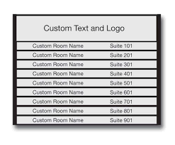 | “Directory Sign” shall mean a sign listing the tenants of a multi-tenant commercial or industrial building containing at least two (2) distinct tenant units which sign includes only the municipal address and a list of tenants or occupancies for identification purposes. |  | 3.8 Exemptions  No permit shall be required…  d. Directory signs. |  | 5.3. Residential Zones  d. Directory signs.
Double Faced Sign |  | 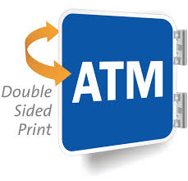 | “Double Faced Sign” shall mean a sign having two (2) sign faces of equal area and proportions which are located exactly opposite each other on the sign structure. (see Sign Area Section 2.15)  This sign could be a billboard, civic address sign, contractor sign, ground sign, hanging sign, election sign, memorial sign, mobile sign, or poster panel. See specific rules for the type of sign. |  | 2.15 “Sign Area” shall mean the area of the surface, structure and/or component part that is used as a visual medium or display. For the purpose of this By-law, any double-sided sign shall be deemed to have only one face, provided that the faces are identical, contiguous, and/or  diverging at an angle of not more than fifteen (15) degrees.  3.14 Illumination  a. Signs may be illuminated unless otherwise expressly prohibited by this By-law.  b. No illumination of a sign shall spill beyond the face of the sign such that light interferes with the enjoyment of neighbouring lands or interferes with the visibility on nearby streets. |  | Zone varies by sign type  See sign type for rules.
Election Sign |  | 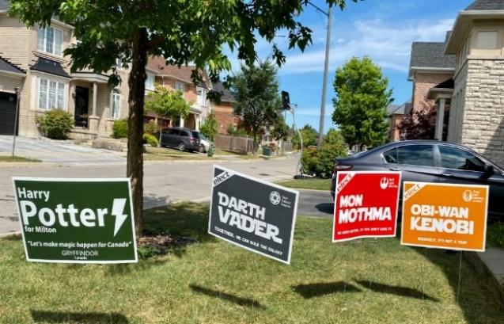 | “Election Sign” shall mean a sign which is used to promote the running candidate for public office in a federal, provincial, municipal, or School Board election period and signs used in relation to a referendum. |  | 3.8 Exemptions  No permit shall be required…  4.6 Election Signs  Election Signs for Federal, Provincial, Municipal, or School Board elections are regulated through legislation and in addition shall be subjected to the following:  a. Election signs must be removed within seventy-two (72) hours after election polls close;  b. Sandwich boards, portable/mobile signs, electronic message display signs and readograph signs are prohibited for election use;  c. Election signs are not permitted within any municipal road allowance;  d. No election sign shall be located as to interfere with the safe operation of vehicular and pedestrian traffic and any sign improperly located may be removed by Municipal Staff or his/her designate;  e. No election sign shall be erected in any sight triangle;  f. No election sign shall be erected at, adjacent to, or within 18 metres of polling stations. The Chief Building Official or his/her designate has the authority to remove these election signs immediately without notice;  g. The Chief Building Official has the authority to immediately remove any election sign that is not in compliance with the requirement of this By-law; and  h. No election sign shall be erected within any municipal property, including election-oriented vehicle wrapping signage. |  | 5.3. Residential Zones
Electronic Message Display |  | 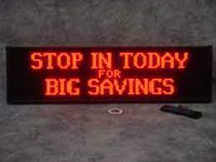 | “Electronic Message Display” shall mean a sign or part of a sign which is electronically controlled to display information in a pre-arranged sequence. |  | 4.2 Readographs, and Electronic Message Displays  a. Readographs and Electronic Message Displays shall only be permitted in commercial, employment and institutional zones.  b. A ground sign incorporating a readograph or an electronic message display shall be subject to the provisions of section 4.4 (Ground Signs) of this By law, except that the maximum permitted sign area for a ground sign incorporating a readograph or electronic message display shall be 25 percent greater than the maximum permitted sign area that does not incorporate a readograph or an electronic message display.  c. The intensity of illumination of an electronic message display during a cycle shall be maintained at a constant level. In addition, such signs shall come equipped with automatic dimming technology that automatically adjusts the signs brightness in direct correlation with ambient light conditions.  d. The information displayed on an electronic message display shall be static for at least 6 seconds per message. |  | 5.4. Institutional Zones  5.5. Commercial and Employment Zones  5.7. Community Improvement Plan Areas  See C.I.P in the “Rules” section above.
Facia Signs |  |  | “Fascia Sign” shall mean a single faced accessory sign which is painted directly onto a building façade or attached directly to the wall of a building and which does not project more than 0.3 metres from the building. Any message displayed on an awning or marquee, whether projecting over a street or not, shall be deemed a fascia sign for the purposes of this By-law. |  | 4.3 Fascia Signs  a. A fascia sign may only be erected or displayed on that portion of an exterior wall which is adjacent to that business and only when the wall faces a street, public lane, public parking lot or private parking lot.  b. A fascia sign shall be permitted in any commercial, employment and institutional facility zone.  c. A fascia sign shall only be permitted for the purpose of providing a notice of the use or occupancy of the building for which it is attached.  d. A fascia sign may be erected above the first storey of any building, with a minimum clear height of 2.7 metres.  e. The total sign area of all fascia signs on a building shall not exceed 25 percent of the wall area of the first storey.  f. Directional fascia signs shall be permitted in the parking areas of restaurants, multiple unit retail establishments, employment areas and multiple unit residential buildings, which shall not exceed 0.6 square metres in sign area.  g. Fascia signs shall be anchored safely and securely to the exterior wall of a building that is capable of carrying this additional load by means of approved fastener.  h. A fascia sign shall not project more than 0.3 metres from the wall of a building to which it is attached.  i. Each lot shall be limited to two (2) fascia signs or one fascia sign for each business operation. An additional fascia sign is permitted for each additional street frontage.  j. A fascia sign shall not exceed the height of the wall to which it is attached.  3.14 Illumination  a. Signs may be illuminated unless otherwise expressly prohibited by this By-law.  b. No illumination of a sign shall spill beyond the face of the sign such that light interferes with the enjoyment of neighbouring lands or interferes with the visibility on nearby streets. |  | 5.4. Institutional Zones  5.5. Commercial and Employment Zones  5.6. Rural and Agricultural Zones  c. Fascia signs erected on a barn or other accessory building or structure used to advertise the name of the farm or the identity of the operators, having a maximum sign area of 14 square metres  5.7. Community Improvement Plan Areas  See C.I.P in the “Rules” section above.
Farm Produce Sign |  |  | Signs that are used to advertise the sale of fresh farm products |  | 3.8 Exemptions  No permit shall be required…  k. Signs that are used to advertise the sale of fresh farm products provided the total area of the sign does not exceed 1.5 square metres. |  | 5.6. Rural and Agricultural Zones  g. Signs that are used to advertise the sale of fresh farm products provided the total area of the sign does not exceed 1.5 square metres.
Fence Sign  3.15 Prohibited Signs |  |  | “Fence Sign” shall mean a single- or double-faced sign which has been affixed to a fence. |  | 3.15 Prohibited Signs  q. A fence sign.  Clarification:  A private warning sign such as “No Trespassing” or “Danger – Do Not Enter” would be examples of signs that would be allowed on a fence. See Private Warning Signs for more details.
Ground Sign |  | 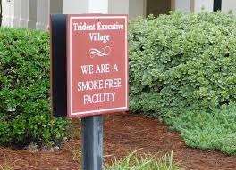 | “Ground Sign” shall mean a single- or double-faced on-premise sign which rests on the ground or is mounted on one or more poles where the sign has a clear height of less than 3.0 metres. |  | 4.4 Ground Signs  a. Ground signs shall be permitted in any commercial, employment and institutional facility zone.  b. One ground sign shall be permitted on a property with frontage on a municipal highway. If a property has frontage on more than one municipal highway, one sign for each frontage shall be permitted on that property.  c. A ground sign on a property with frontage of less than 30.0 metres shall not exceed 5.5 metres in height, and shall not exceed 5.5 square metres in sign area.  d. For each additional 5.0 metres of frontage, an additional 0.5 metres of height shall be permitted, to a maximum height of 8.0 metres. Further, an additional 0.5 square metres in area shall be permitted, to a maximum area of 7.0 square metres.  e. One off premises ground sign shall be permitted on a property that is undeveloped, which shall not exceed 5.0 square metres in sign area.  f. A ground sign shall be located at least 3.0 metres from the property line of any adjacent residence.  g. A ground sign shall be located at least 1.5 metres from the property line of any adjacent commercial, employment, institutional zone or municipal public right of way.  h. Ground signs shall be set in concrete footings which shall extend below the depth of frost penetration and shall be of sufficient size and weight to prevent overturning of the sign.  i. Where required by the Chief Building Official or his/her designate, ground signs shall be designed by a professional engineer when required by the Ontario Building Code.  3.10 Location of Signs  No sign shall be located in such a manner as to impede the view of any highway intersection or railroad grade crossing or any ingress and/or egress from private or public property or where, in the opinion of the road authority having jurisdiction, it may be confused with or impair the view of any authorized traffic sign, signal or device. If a sign falls within jurisdiction of another governmental authority, input from the applicable  authority will be sought.  3.14 Illumination  a. Signs may be illuminated unless otherwise expressly prohibited by this By-law.  b. No illumination of a sign shall spill beyond the face of the sign such that light interferes with the enjoyment of neighbouring lands or interferes with the visibility on nearby streets. |  | 5.4. Institutional Zones  5.5. Commercial and Employment Zones  5.6. Rural and Agricultural Zones  d. Ground signs used for personal identification, not exceeding 2.3 square metres  5.7. Community Improvement Plan Areas  See C.I.P in the “Rules” section above.
Hanging Sign |  | 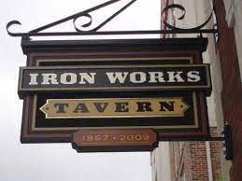 | “Hanging Sign” shall mean a sign which is attached perpendicular to the wall of a building, which overhangs a sidewalk or other pedestrian walkway and is fixed to prevent swinging. |  | 4.8 Hanging Signs  a. Hanging signs shall be permitted in any commercial, institutional or employment zone.  b. The maximum area of a hanging sign shall not exceed 1 .5 square metres.  c. A hanging sign shall be firmly anchored to a building face.  d. The sign shall have a minimum clearance above grade of 2.4 metres.  e. A hanging sign shall not be constructed as a swing sign.  3.14 Illumination  a. Signs may be illuminated unless otherwise expressly prohibited by this By-law.  b. No illumination of a sign shall spill beyond the face of the sign such that light interferes with the enjoyment of neighbouring lands or interferes with the visibility on nearby streets. |  | 5.4. Institutional Zones  5.5. Commercial and Employment Zones  5.7. Community Improvement Plan Areas  See C.I.P in the “Rules” section above.  .
Home Business Sign |  |  | “Home Business Sign” shall mean a sign for the identification of a home business.  …. non-illuminated and not exceeding 1 square metre  See the particular sign type being used for more details.  NOTE:  Where there is a conflict, the most restrictive bylaw applies. In this case it would be the Home Business sign rules that would apply to size and no illumination. |  | 3.10 Location of Signs  No sign shall be located in such a manner as to impede the view of any highway intersection or railroad grade crossing or any ingress and/or egress from private or public property or where, in the opinion of the road authority having jurisdiction, it may be confused with or impair the view of any authorized traffic sign, signal or device. If a sign falls within jurisdiction of another governmental authority, input from the applicable  authority will be sought. |  | 5.3. Residential Zones  Home occupation signs, non-illuminated and not exceeding 1 square metre as per Zoning By-law No. 2018-58 and its amendments;
Illuminated Sign |  |  | “Illuminated Sign” shall mean a sign which is illuminated directly, indirectly, internally or externally by fluorescent lamps or luminous tubes. |  | For externally illuminated signs (Floodlights or overhead Lighting),  3.14 Illumination  a. Signs may be illuminated unless otherwise expressly prohibited by this By-law.  b. No illumination of a sign shall spill beyond the face of the sign such that light interferes with the enjoyment of neighbouring lands or interferes with the visibility on nearby streets. |  | 5.4. Institutional Zones  5.5. Commercial and Employment Zones  5.7. Community Improvement Plan Areas  See C.I.P in the “Rules” section above.
Inflatable Sign  3.15 Prohibited Signs |  | 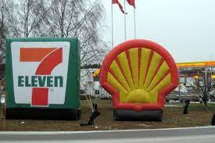 | “Inflatable Sign” shall mean a sign designed to be airborne and tethered to the ground, a vehicle, or any other structure and shall include balloons and any other inflatable Sign. |  | 3.15 Prohibited Signs  d. An inflatable advertising sign
Inside Signs |  |  | All signs in the interior of buildings, whether they can be seen from the outside or not, including window painted signs. |  | 3.8 Exemptions  No permit shall be required…  h. All signs in the interior of buildings, whether they can be seen from  the outside or not, including window painted signs. |  | 5.7. Community Improvement Plan Areas  See C.I.P in the “Rules” section above.
Marquee |  | 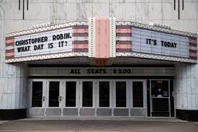 | “Marquee” shall mean a permanent roof structure constructed of metal,  wood, plastic, plaster or similar materials projecting from, attached to  and supported by a building, upon which there may be one or more sign  faces. |  | See also – “Fascia Sign” for details  o. “Fascia Sign” … Any message displayed on an awning or marquee, whether projecting over a street or not, shall be deemed a fascia sign for the purposes of this By-law. |  | 5.4. Institutional Zones  5.5. Commercial and Employment Zones  5.7. Community Improvement Plan Areas  See C.I.P in the “Rules” section above.
Memorial Sign |  | 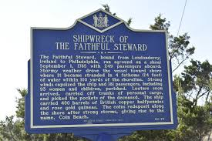 | Memorial or commemorative signs or tablets, ground mounted or  permanently attached or architecturally integrated into a building. |  | 3.8 Exemptions  No permit shall be required…  f. Memorial or commemorative signs or tablets, ground mounted or permanently attached or architecturally integrated into a building. |  | 5.2 Permitted in all zones except Natural Core.
Mobile Sign |  | 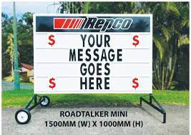 | “Mobile Sign” shall mean a sign mounted on or connected to a trailer or other type of structure which is not permanently anchored in the ground and is designed in such a manner as to facilitate its movement from place to place for the purpose of advertising on a temporary basis, but shall not include a sandwich board, or real estate sign. |  | 4.1 Mobile Signs  A permitted mobile sign may be displayed for a period of ninety (90) days per calendar year (Jan 1, to Dec 31st) at one location.  4.1.1. Number of Signs  a. A maximum of 1 mobile sign shall be permitted on a lot having a street frontage of 121 metres or less.  b. A maximum of 2 mobile signs shall be permitted on a lot having a street frontage exceeding 121 metres.  4.1.2. General Provisions  a. It is located on private property;  b. It is displaying a message that logically and clearly indicates that the use is for the subject property;  c. It is in good repair and has not become unsafe, unsightly or dangerous;  d. It is situated at grade;  e. Where it has been leased or rented from a sign company, the name and telephone number of the sign company is affixed to the sign at a clearly visible location;  f. It has no more than two (2) sign faces for which the maximum sign face area shall not exceed 4.6 square metres in which no one dimension is greater than 2.4 metres;  g. Where a business is located on a lot occupied by two (2) or more businesses, no application shall be approved if the total number of signs permitted on that lot would be exceeded until a permit has expired;  h. It is located a minimum of 3 metres from the closest edge of a sidewalk or lot line and at least 23 metres from the closest edge of another mobile sign; and  i. A blank mobile sign shall not be permitted.  3.10 Location of Signs  No sign shall be located in such a manner as to impede the view of any highway intersection or railroad grade crossing or any ingress and/or egress from private or public property or where, in the opinion of the road authority having jurisdiction, it may be confused with or impair the view of any authorized traffic sign, signal or device. If a sign falls within jurisdiction of another governmental authority, input from the applicable  authority will be sought.  . |  | 5.4. Institutional Zones  5.5. Commercial and Employment Zones  5.7. Community Improvement Plan Areas  See C.I.P in the “Rules” section above.
Multi-Faced Sign |  | 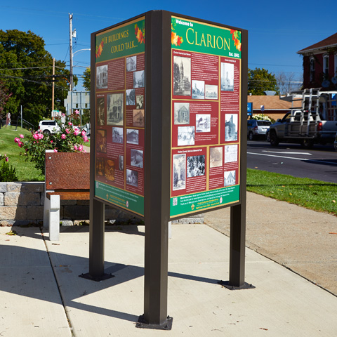 | “Multi-faced Sign shall mean a ground sign having more than two (2) sign faces up to a maximum of four (4) sign faces, each face being of equal area and proportion to the other. |  | 4.4 Ground Signs  a. Ground signs shall be permitted in any commercial, employment and institutional facility zone.  b. One ground sign shall be permitted on a property with frontage on a municipal highway. If a property has frontage on more than one municipal highway, one sign for each frontage shall be permitted on that property.  c. A ground sign on a property with frontage of less than 30.0 metres shall not exceed 5.5 metres in height, and shall not exceed 5.5 square metres in sign area.  d. For each additional 5.0 metres of frontage, an additional 0.5 metres of height shall be permitted, to a maximum height of 8.0 metres. Further, an additional 0.5 square metres in area shall be permitted, to a maximum area of 7.0 square metres.  e. One off premises ground sign shall be permitted on a property that is undeveloped, which shall not exceed 5.0 square metres in sign area.  f. A ground sign shall be located at least 3.0 metres from the property line of any adjacent residence.  g. A ground sign shall be located at least 1.5 metres from the property line of any adjacent commercial, employment, institutional zone or municipal public right of way.  h. Ground signs shall be set in concrete footings which shall extend below the depth of frost penetration and shall be of sufficient size and weight to prevent overturning of the sign.  i. Where required by the Chief Building Official or his/her designate, ground signs shall be designed by a professional engineer when required by the Ontario Building Code.  3.10 Location of Signs  No sign shall be located in such a manner as to impede the view of any highway intersection or railroad grade crossing or any ingress and/or egress from private or public property or where, in the opinion of the road authority having jurisdiction, it may be confused with or impair the view of any authorized traffic sign, signal or device. If a sign falls within jurisdiction of another governmental authority, input from the applicable  authority will be sought.  3.14 Illumination  a. Signs may be illuminated unless otherwise expressly prohibited by this By-law.  b. No illumination of a sign shall spill beyond the face of the sign such that light interferes with the enjoyment of neighbouring lands or interferes with the visibility on nearby streets. |  | 5.4. Institutional Zones  5.5. Commercial and Employment Zones  5.7. Community Improvement Plan Areas  See C.I.P in the “Rules” section above.
Mural |  |  | “Mural” shall mean any type of display or artistic endeavor applied to  any external wall or other part of a building or structure which does not  include any words, images, logos, or trademarks that advertise or  convey any promotional message.
Off-Premise Sign |  | 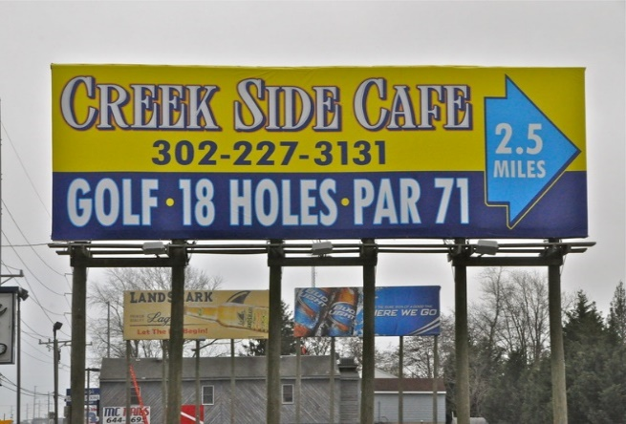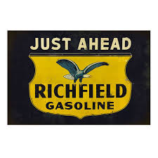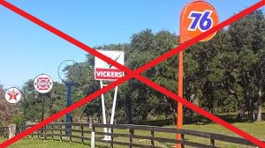 | “Off-Premise Sign” shall mean a sign identifying or advertising a business, person, activity, goods, products or service, which is not related to, or available at the lot where the sign in located.  See specific sign type for further details.  This picture shows too many signs on a lot. |  | 3.10 Location of Signs  No sign shall be located in such a manner as to impede the view of any highway intersection or railroad grade crossing or any ingress and/or egress from private or public property or where, in the opinion of the road authority having jurisdiction, it may be confused with or impair the view of any authorized traffic sign, signal or device. If a sign falls within jurisdiction of another governmental authority, input from the applicable  authority will be sought.  3.11 Number of Signs  a. Off-premise Signs  A maximum of one (1) off-premise sign may be erected or displayed on one lot.  3.14 Illumination  a. Signs may be illuminated unless otherwise expressly prohibited by this By-law.  b. No illumination of a sign shall spill beyond the face of the sign such that light interferes with the enjoyment of neighbouring lands or interferes with the visibility on nearby streets.
On-Premise Sign |  |  | “On-premise Sign” shall mean a sign identifying, advertising, or directing attention to a business, profession, commodity, subject service, or entertainment which is conducted, sold or offered at the lot upon which the sign is located. |  | 3.10 Location of Signs  No sign shall be located in such a manner as to impede the view of any highway intersection or railroad grade crossing or any ingress and/or egress from private or public property or where, in the opinion of the road authority having jurisdiction, it may be confused with or impair the view of any authorized traffic sign, signal or device. If a sign falls within jurisdiction of another governmental authority, input from the applicable  authority will be sought.  3.14 Illumination  a. Signs may be illuminated unless otherwise expressly prohibited by this By-law.  b. No illumination of a sign shall spill beyond the face of the sign such that light interferes with the enjoyment of neighbouring lands or interferes with the visibility on nearby streets. |  | 5.5. Commercial and Employment Zones
Hours of Operation Sign |  |  | Signs erected upon commercial or industrial premises which list only the hours of operation, municipal address, unit number, telephone number, webpage and or email address |  | 3.8 Exemptions  No permit shall be required…  g. Signs erected upon commercial or industrial premises which list only the hours of operation, municipal address, unit number, telephone number, webpage and or email address, providing that the number of such signs does not exceed one per business establishment and that the sign area does not exceed 0.5 square metres. |  | 5.5. Commercial and Employment Zones
Personal Identification Sign |  |  | “Personal Identification Sign” shall mean a single or double-faced on-premise sign that identifies the residential occupants of the lot. |  | 3.8 Exemptions  No permit shall be required…  a. Personal identification signs having a maximum sign area of 0.5 square metres. |  | 5.3. Residential Zones  5.6. Rural and Agricultural Zones
Pole or Tree Sign  3.15 Prohibited Signs |  | 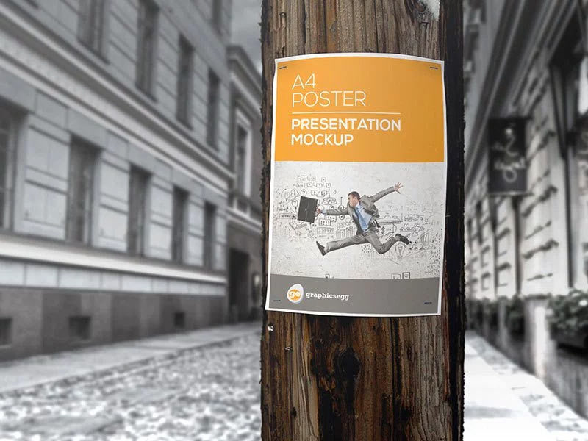 |  |  | 3.15 Prohibited Signs  p. Except for a public information sign, banner or sign pertaining to public safety, no person shall attach or display any sign or advertisement on a utility pole, light standard, or live tree except as provided for hereafter.
Poster Panel |  |  | “Poster Panel Sign” shall mean a single or double faced Off-premise sign which is used for the display of a message produced on a sheet of paper that may be either self-supporting or affixed to a building or other structure for support. |  | 4.7 Poster Panel Signs  a. Poster panel signs shall be permitted in any commercial or employment zone.  b. Only one poster panel sign shall be permitted on a lot.  c. The regulations contained within Section 4.4 Ground Signs as they relate to sign height, sign area and location apply equally to Poster Panel Signs. |  | 5.5. Commercial and Employment Zones
Private Warning Sign |  | 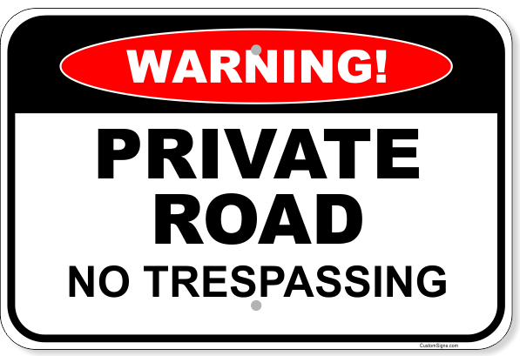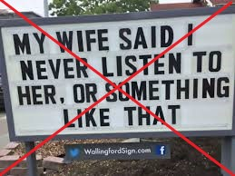 | “Private Warning Sign” shall mean a single faced On-premise sign that directs a warning to the public such as no trespassing, beware of dog, no hunting or similar warnings.  Although this a good example of a warning sign that something bad is going to happen, it is not intended to be an example of a Private Warning Sign as described in the Sign By-law. |  | 5.2.5. Warning Signs  a. Warning signs shall have a maximum sign area of 0.5 metres.  3.8 Exemptions  No permit shall be required…  c. Private Warning signs or other such directional signs regulating the use of the property. |  | 5.2 Permitted in all zones except Natural Core.  5.7. Community Improvement Plan Areas  See C.I.P in the “Rules” section above.
Public Information Sign |  | 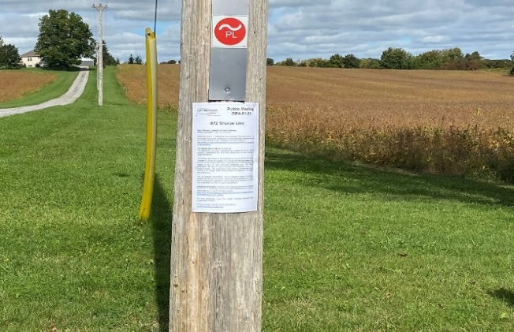 | “Public Information Sign” shall mean any sign erected for or at the direction of any government authority, agency, board or committee for the purpose of providing information to the public concerning such authority, agency, board or committee or any proceedings thereof and shall include signs that advertise Planning Act applications.  This is usually found on a pole or tree, on the subject property and visible from the road. |  |  |  | 5.2 Permitted in all zones except Natural Core.
ReadographSign |  | 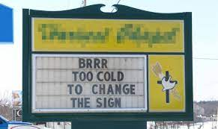 | “Readograph” shall mean a sign or part of a sign on which copy is changed manually with letters or pictorial panels. |  | 4.2 Readographs, and Electronic Message Displays  a. Readographs and Electronic Message Displays shall only be permitted in commercial, employment and institutional zones.  b. A ground sign incorporating a readograph or an electronic message display shall be subject to the provisions of section 4.4 (Ground Signs) of this By law, except that the maximum permitted sign area for a ground sign incorporating a readograph or electronic message display shall be 25 percent greater than the maximum permitted sign area that does not incorporate a readograph or an electronic message display.  c. The intensity of illumination of an electronic message display during a cycle shall be maintained at a constant level. In addition, suchsigns shall come equipped with automatic dimming technology that automatically adjusts the signs brightness in direct correlation with ambient light conditions.  d. The information displayed on an electronic message display shall be static for at least 6 seconds per message |  | 5.4. Institutional Zones  5.5. Commercial and Employment Zones
Real estate Sign |  |  | “Real Estate Sign” shall mean a temporary sign located on a lot for the purpose of announcing a sale, lease, or rental of such lot or a building or structure located thereon. |  | 3.8 Exemptions  No permit shall be required…  b. Real estate, restricted to the size and definition provided by the Chief Building Official or his/her designate. (not exceeding 0.5 square metres.) |  | 5.2 Permitted in all zones except Natural Core.  5.2.1. Real Estate Signs  a. Real estate signs shall be permitted in any zone on a lot which is for sale or available for lease or rent, and shall be removed within twenty-one (21) days following the confirmation of a sale or the leasing of the premises;  b. Real estate signs shall not have a sign area exceeding 0.5 square metres. metres, except in a commercial or employment zone, where the sign area shall not exceed 3 square metres; and  c. A maximum of one (1) real estate sign per lot shall be permitted, except where there is separate street or water frontage, at which point one additional sign per street or water frontage will be  permitted.
Sandwich Board |  | 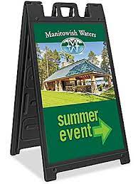 | “Sandwich Board” shall mean a sign which is secured but not permanently affixed to the ground. Being self-supportive, it forms the shape of an ‘A’ when erected. Its size and shape shall be limited to a maximum of 1.2 metres in height and 0.6 metres in width for each Sign Face. |  | 4.5 Sandwich Board Signs  a. A sandwich board sign shall be permitted on Municipal Property during regular business hours only where an encroachment agreement has been entered into with the Corporation.  b. A maximum of one (1) sandwich board sign per business may be erected or displayed within the municipal limits.  c. Sandwich board signs must be removed from public property after business hours |  | 5.7. Community Improvement Plan Areas  See C.I.P in the “Rules” section above.
Temporary Sign |  |  | “Temporary Sign” shall mean a sign which is intended to advertise community events or civic projects, or promote patriotic, religious or charitable events on a temporary basis. |  | 3.8 Exemptions  No permit shall be required…  j. Temporary signs, subject to their removal within one (I) week of the conclusion of the special event.
Vehicle Sign  3.15 Prohibited Signs |  | 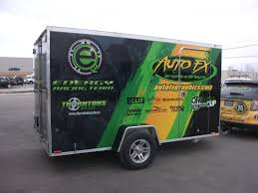 | See next panel for stipulations. |  | 3.15 Prohibited Signs  e. A sign erected or painted on a vehicle or trailer where the vehicle or trailer is not in weekly operation for transportation and is parked in a manner so as to make the sign visible from a street for the purpose of functioning as an identification, information or advertising sign
Window Sign |  |  | Included in Inside Signs - See More Examples |  | 3.8 Exemptions  No permit shall be required…  h. All signs in the interior of buildings, whether they can be seen from the outside or not, including window painted signs. |  | 5.7. Community Improvement Plan Areas  See C.I.P in the “Rules” section above.
Yard Sale Sign |  | 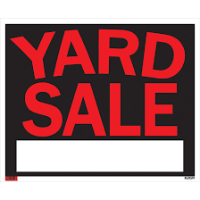 | “Yard Sale Sign” shall mean a sign which is used solely for the purpose of directing traffic to the location of a yard, garage, household, or auction sale. Such signs may include the name of the event holder, and the location and/or time of the event but shall contain no other message. Such sign shall be removed immediately following the closure of the event. |  |  |  | 5.3. Residential Zones

